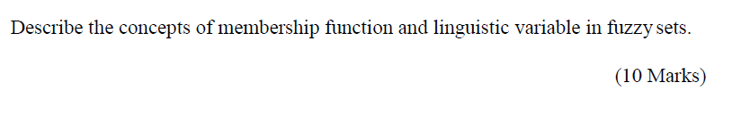

When we try to convert the expert knowledge into fuzzy inference rules, we need to deal with human language. Linguistic variables in fuzzy sets are variables whose values are words or sentences in a natural human language rather than numerical value. For instance, age, in linguistic variables can refer to ‘very young’, ‘young’, ‘old’, ‘very old’, and etc. Membership function can be used to give each linguistic variable in fuzzy sets a meaning. The membership function of a fuzzy set is a generalisation of the indicator function for classical sets. In fuzzy logic, it represents the degree of truth as an extension of valuation. **(give examples of the age fuzzy membership function)**

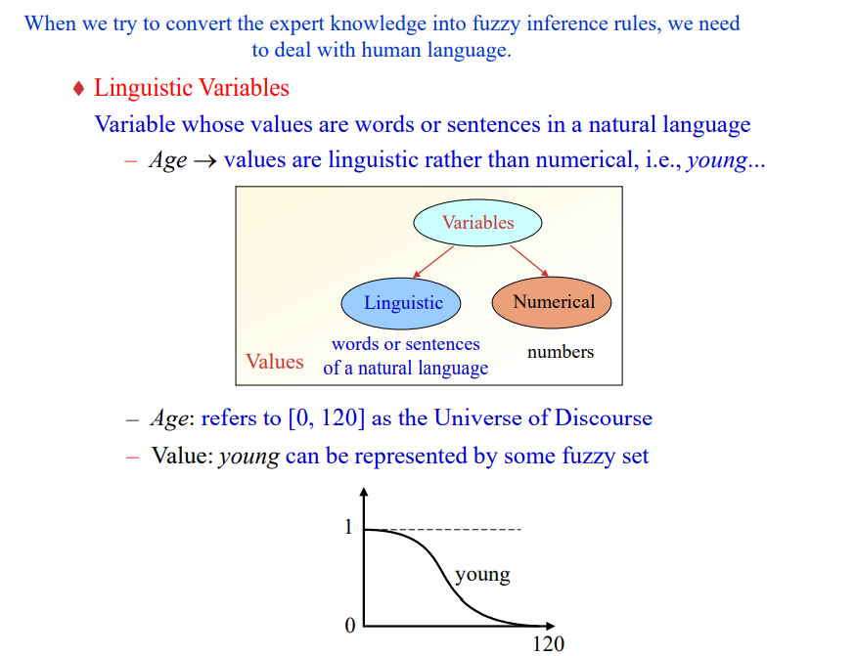

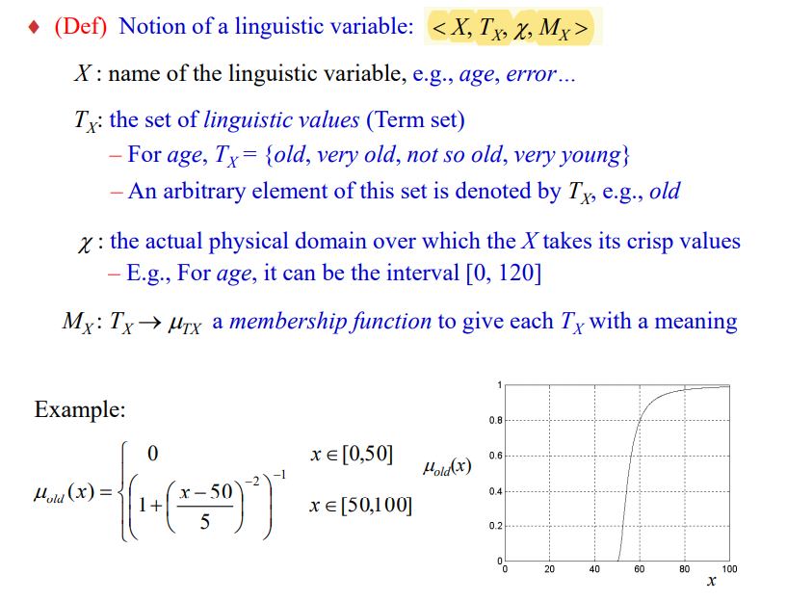

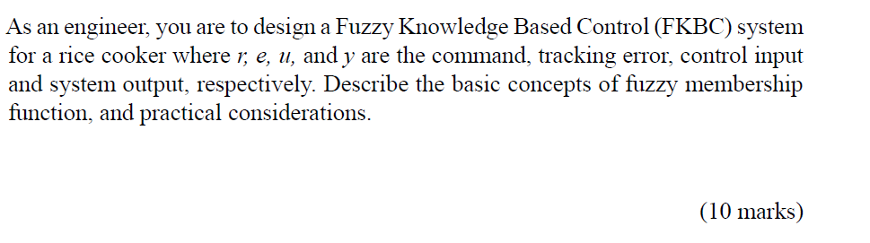

Membership function can be used to give each linguistic variable in fuzzy sets a meaning. The membership function of a fuzzy set is a generalisation of the indicator function for classical sets. In fuzzy logic, it represents the degree of truth as an extension of valuation. Instead of identifying the error as a numerical value, we used linguistic variable to define and categorise the extent of error in the rice cooker. The error could be classified as negative big (NB), negative medium (NM), negative small (NS), zero (ZO), positive big (PB), positive medium (PM) and positive big (PB). **(give example of the membership function for the rice cooker example, just talk about the tracking error will do)**

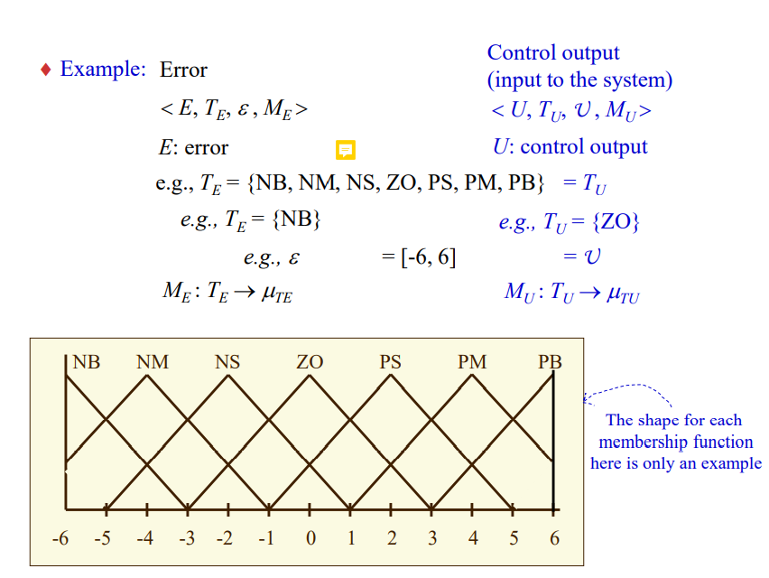

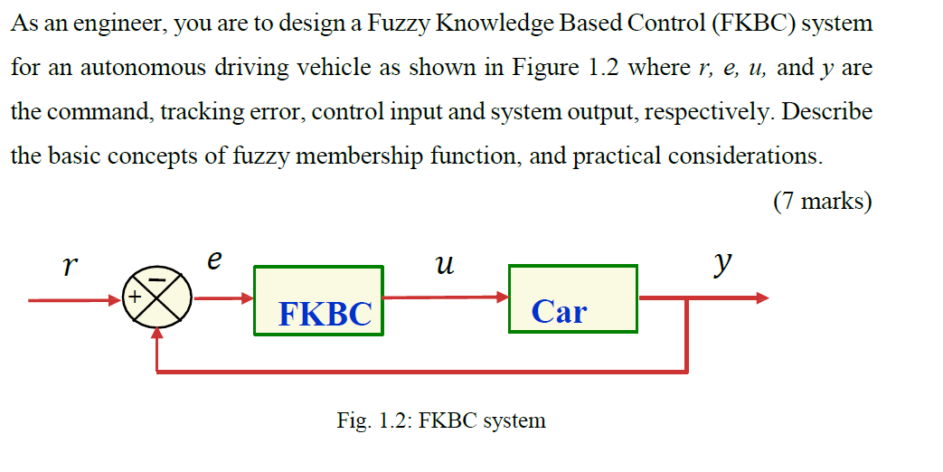

Membership function can be used to give each linguistic variable in fuzzy sets a meaning. The membership function of a fuzzy set is a generalisation of the indicator function for classical sets. In fuzzy logic, it represents the degree of truth as an extension of valuation. Instead of identifying the error as a numerical value, we used linguistic variable to define and categorise the extent of error in the rice cooker. The error could be classified as negative big (NB), negative medium (NM), negative small (NS), zero (ZO), positive big (PB), positive medium (PM) and positive big (PB). **(give example of the membership function for the autonomous driving vehicle example, just talk about the tracking error will do)**



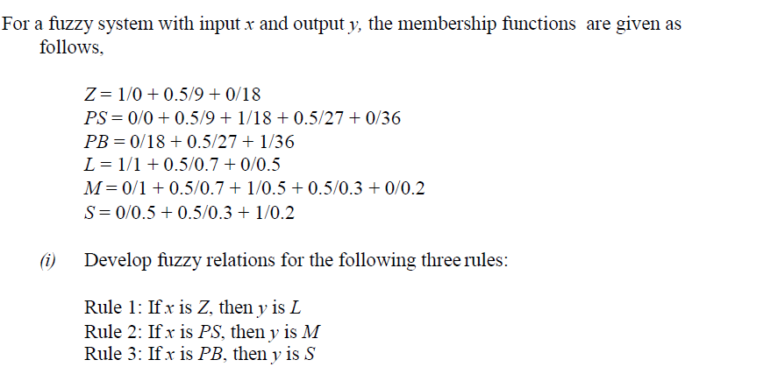

**uR(x,y) = min(uz(x), uL(y))**

**uR(x,y) = min(uPS(x), uM(y))**

**uR(x,y) = min(uPB(x), uS(y))**

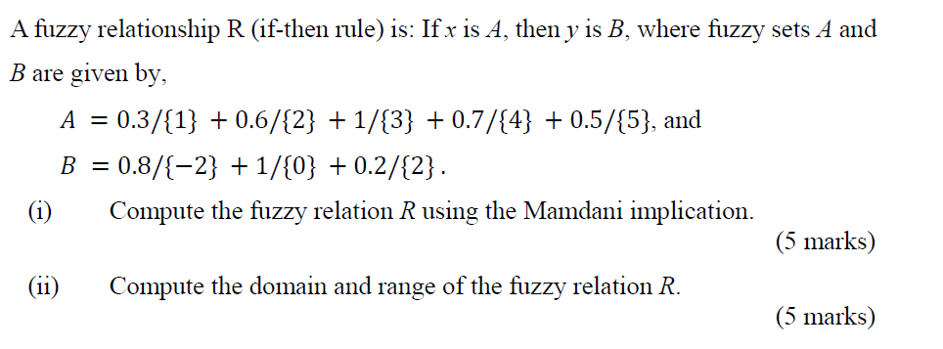

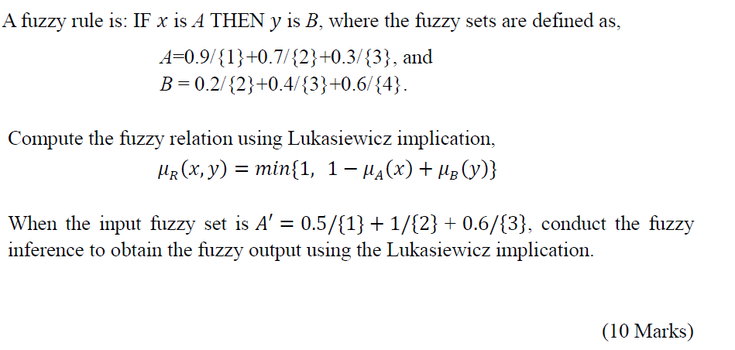

**Find fuzzy relation first. Then, do the matrix multiplication and find the output**